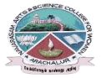
NAVARASAM ARTS AND SCIENCE COLLEGE FOR WOMEN
ARACHALUR, ERODE-638101
STAFF PROFILE
Name | Mrs. S. RADHIKA |  |  | 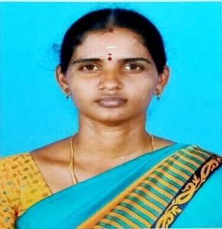
Designation | ASSISTANT PROFESSOR
Qualification | M.Com (CA)., M.Phil.,
Department | COMMERCE
Phone No. | Office
 | Mobile | 9965054567
Email | 1. radhisasi90@gmail.com  2.
Areas of Interest/  Specialization | Finance
Subjects Taught | UG: 1. Advanced Accounting I  2. Advanced Accounting II  3. Corporate Accounting  4. Principles of Auditing  5. Indirect taxes  6. Financial Management  7. Business law  8.Financial Accounting  9. Cost Accounting  10.Management Accounting  PG: 1. Financial and Investment Management
Date of Joining in our Institution | 20.09.2021
Experience (in Years) | Industry |  | -
 | Teaching |  | 3 YEARS
 | Research |  | -
 | Total |  | -
- Research Publications in Journals | NIL
Papers Published in Conference Proceedings | NIL
Books / Chapters  Published | NIL
Patent Published | NIL

Research Projects  Major/ Minor | Completed |  | NIL
 | Undergoing |  | NIL
Research Guidance | Awarded |  | Undergoing
 | NIL |  | NIL
Conferences | Attended | Presented |  |  | Organized
National | NIL | NIL |  |  | NIL
International | NIL | NIL |  |  | NIL
Workshops | Attended |  |  | Organized
 | - |  |  | -
FDP | Attended |  |  | Organized
 | Microsoft digital skills |  |  | NIL
Seminar / Webinar | Attended |  |  | Organized
 | NIL |  |  | NIL
Membership | NIL
Acted as Resource Person | NIL
Awards | NIL
Online Courses | Completed |  |  | Enrolled
 | NIL |  |  | NIL
Extension Activities (NSS/YRC) / Club In charge | Scholarship Coordinator  Cozy Stitches Club
Administrative Assignments Handled | NIL
Association with Professional Bodies | NIL
Anyother Achievements | NIL
Orchid / Google Scholar/  Research ID | NIL

