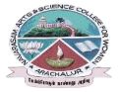
NAVARASAM ARTS AND SCIENCE COLLEGE FOR WOMEN
ARACHALUR, ERODE-638101
STAFF PROFILE
Name |  | Ms.P.Aishwarya  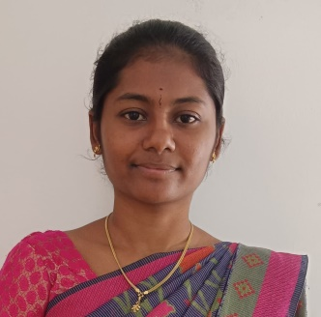
Designation |  | Assistant Professor in Commerce
Qualification |  | M.Com(CA),(Ph.D).,
Department |  | Commerce
Phone No. |  | Office
 |  | Mobile | 6374828428
Email |  | - Aishwarya6063@gmail.com
Areas of Interest/  Specialization |  | Finance and Marketing
Subjects Taught |  | UG: PG: Nil  - Financial Accounting – I  - Financial Accounting – II  - Business Law  - Income Tax Law and Practice  - Commercial Law  - Actuarial Statistics  - Agriculture Economy of India
Date of Joining in our Institution |  | 07.06.2023
Experience (in Years) |  | Industry |  | Nil
 |  | Teaching |  | 1 Year and 6 Months
 |  | Research |  | Nil
 |  | Total |  | 1 Year and 6 Months
Research Publications in Journals |  | Nil
Papers Published in Conference Proceedings |  | Nil
Books / Chapters  Published |  | Nil
Patent Published |  | Nil
Research Projects  Major/ Minor | Completed |  |  |  |  | Nil
 | Undergoing |  |  |  |  | Nil
Research Guidance | Awarded |  |  |  |  | Undergoing
 | Nil |  |  |  |  | Nil
Conferences | Attended |  |  |  | Presented |  |  | Organized
National | - Innovation & Entrepreneurship in Logistics Management  - Innovation in Business and Economy – Opportunities and challenges  - National commission for women  “ Effective breast cancer awareness programme”. |  |  |  | Nil |  |  | Nil
International | Nil |  |  |  | Nil |  |  | Nil
Workshops | Attended |  |  |  |  |  | Organized
 | Nil |  |  |  |  |  | Nil
FDP | Attended |  |  |  |  |  | Organized
 | Insurance Services and Operations(Naan Mudhalvan) |  |  |  |  |  | Nil
Seminar / Webinar | Attended |  |  |  |  |  | Organized
 | - National stock exchange sponsored webinar on “ Investment awareness program” |  |  |  |  |  | Nil
Membership | Nil
Acted as Resource Person | Nil
Awards | Awarded University Rank IV in UG.  Awarded University Rank II in PG.
Online Courses | Completed |  |  |  |  |  | Enrolled
 | Integrated Marketing Management (NPTEL SWAYAM) |  |  |  |  |  | Nil
Extension Activities (NSS/YRC) / Club In charge | Nil
Administrative Assignments Handled | Nil
Association with Professional Bodies | Nil
Any other Achievements | Nil
Orchid / Google Scholar/  Research ID | Nil

