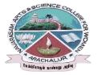
NAVARASAM ARTS AND SCIENCE COLLEGE FOR WOMEN
ARACHALUR, ERODE-638101
STAFF PROFILE
Name | 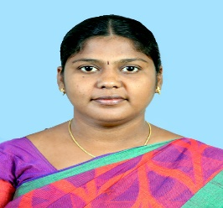  Mrs. M. BRINDHA
Designation | ASSISTANT PROFESSOR
Qualification | M.COM CA., M.Phil., (Ph.D)
Department | COMMERCE
Phone No. | Office
 | Mobile | 9524358223
Email | 1. brindhakavin23@gmail.com  2. mphilbrindha@gmail.com
Areas of Interest/  Specialization | Finance and Marketing
Subjects Taught | UG: PG:  Corporate accounting Corporate accounting  Software development with VB Java programming with HTML  Principles of marketing Information Technology in Business  Business Finance Introduction to Industry 4.0  Executive Business Communication
Date of Joining in our Institution | 1.6.2012
Experience (in Years) | Industry
 | Teaching |  | 12 years
 | Research |  | 6 years
 | Total |  | 12 years
Research Publications in Journals | 3
Papers Published in Conference Proceedings | 2
Books / Chapters  Published | -
- Patent Published | -

Research Projects  Major/ Minor | Completed |  | -
 | Undergoing |  | -
Research Guidance | Awarded |  | Undergoing
 | M.Phil 1 |  | -
Conferences | Attended | Presented |  |  | Organized
National | 8 | 8
International | 5 | 5
Workshops | Attended |  |  | Organized
 | 5
FDP | Attended |  |  | Organized
 | 10 |  |  | -
Seminar / Webinar | Attended |  |  | Organized
 | 18 |  |  | 1
Membership | First Rank holder in M.COM CA in Vellalar College for women in (2009-2011)
Acted as Resource Person | -
Awards | -
Online Courses | Completed |  |  | Enrolled
 | NPTEL AICTE online course on Eight week course - Service Marketing: integrating people, Technology, strategies  NPTEL AICTE online course on Twelve week course – Leadership and Team Effectiveness |  |  | -
Extension Activities (NSS/YRC) / Club In charge | -
Administrative Assignments Handled | Member in College Exam committee since 2014
Association with Professional Bodies | -
Any other Achievements | -
Orchid / Google Scholar/  Research ID | https://scholar.google.com/citations?hl=en&user=v2FXkUUAAAAJ

