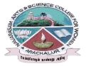
NAVARASAM ARTS AND SCIENCE COLLEGE FOR WOMEN
ARACHALUR, ERODE-638101
STAFF PROFILE
Name | Mrs.S.PRIYA  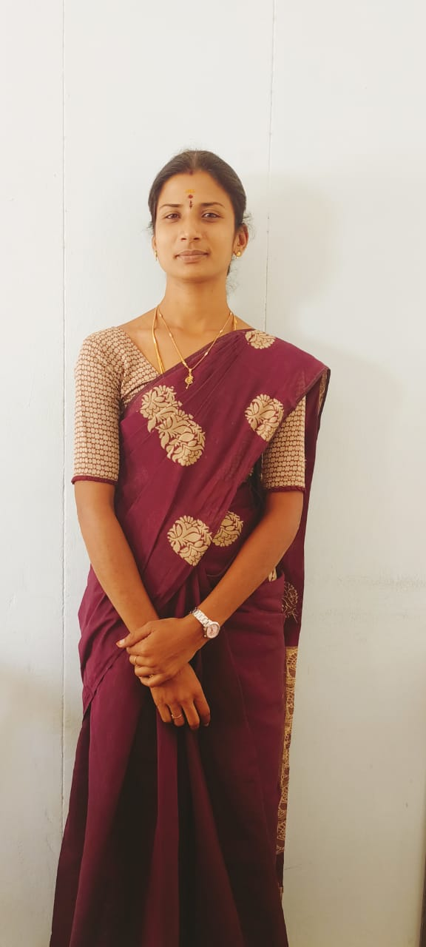
Designation | ASSISTANT PROFESSOR
Qualification | M.A.,B.Ed.,M.Phil.,
Department | ENGLISH
PhoneNo. | Office
 | Mobile | 9524778916
Email | 1.priya.engma@gmail.com
AreasofInterest/  Specialization | Indian literature
SubjectsTaught | UG: Prose,Fiction,Drama,Poetry,Communicative English,American Literature,Indian Writing in English  PG:Research methodology, American Literature ,British literature,Medical Transcription,Indian writing in English
Date of Joining in our Institution | 05.11.2012
Experience(inyears) | Industry
 | Teaching |  | 10 years
 | Research |  | 4 years
 | Total |  | 10 years
ResearchPublications inJournals | 5
PapersPublishedinConferenceProceedings | NIL
Books / Chapters  Published | NIL
ResearchProjects  Major/ Minor | Completed |  |  | NIL
 | Undergoing |  |  | NIL
ResearchGuidance | M. Phil. |  |  | Ph.D.
Awarded | 2 |  |  | NIL
Undergoing | NIL |  |  | NIL
Conferences | Attended | Presented |  | Organized
National | 81  05 | NIL |  | NIL
International | 05 | 04 |  | 01
Workshops | Attended |  | Organized
 | 07 |  | 03
FDP | Attended |  | Organized
 | 25 |  | NIL
Seminar/Webinar | Attended |  | Organized
 | 35 |  | 01
Membership | NIL
Acted as Resource Person | NIL
Awards | NIL
Online Courses | Completed |  | Enrolled
 | 06 |  | NIL
Extension Activities (NSS/YRC) / Club In charge | Beautician club co- ordinator  NSS Program officer  Skill Development Program co- ordinator
Administrative Assignments Handled | Shakespeare Institute Exam co- ordinator
Association with Professional Bodies | NIL
Any other Achievements
Orchid / Google Scholar/  Research ID | priya1988@navarasam.edu.in

