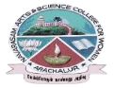
NAVARASAM ARTS AND SCIENCE COLLEGE FOR WOMEN
ARACHALUR, ERODE-638101
STAFF PROFILE
Name | MRS.V.VINODHINI  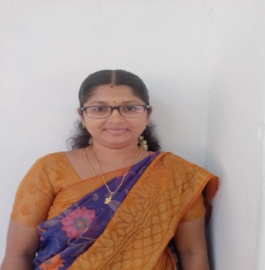
Designation | Assistant Professor
Qualification | M.A., M Phil.,
Department | English
PhoneNo. | Office | -
 | Mobile | 9976904466
Email | vinodhini47@gmail.com  vinodhiniramesh001@gmail.com
Areas of Interest/  Specialization | African Literature
Subjects Taught | UG: English for Competitive Examinations, History of English Literature, Fiction  PG: -
Date of Joining in our Institution | 22.07.2024
Experience(in years) | Industry |  | -
 | Teaching |  | 1 year 7 months
 | Research |  | -
 | Total |  | 1 year 7 months
Research Publications in Journals | NIL
Papers Published in Conference Proceedings | NIL
Books / Chapters  Published | NIL
Patent Published | NIL
Research Projects  Major/ Minor | Completed |  |  | NIL
 | Undergoing |  |  | NIL
Research Guidance | Awarded |  |  | Undergoing
 | - |  |  | NIL
Conferences | Attended | Presented |  | Organized
National | 81  -  --  02  F | NIL |  | NIL
International | 01 | - |  | -
Workshops | Attended |  | Organized
 | 04 |  | -
FDP | Attended |  | Organized
 | 06 |  | -
Seminar/Webinar | Attended |  | Organized
 | 05 |  | -
Membership | NIL
Acted as Resource Person | NIL
Awards | NIL
Online Courses | Completed |  | Enrolled
 | NIL |  | NIL
Extension Activities (NSS/YRC) / Club In charge | NIL
Administrative Assignments Handled | Internal Complaint Committee  Women’s Counseling Cell  Alumni Association
Association with Professional Bodies | -
Any other Achievements | -
Orchid / Google Scholar/  Research ID | -

