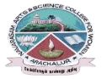
NAVARASAM ARTS AND SCIENCE COLLEGE FOR WOMEN
ARACHALUR, ERODE-638 101
STAFF PROFILE
Name | Mr.G.Balakrishnan
Designation | Assistant Professor and Head Photo
Qualification | M.Sc., M.Phil., copy
Department | Computer Science
Phone No. | Office | 0424-2757209  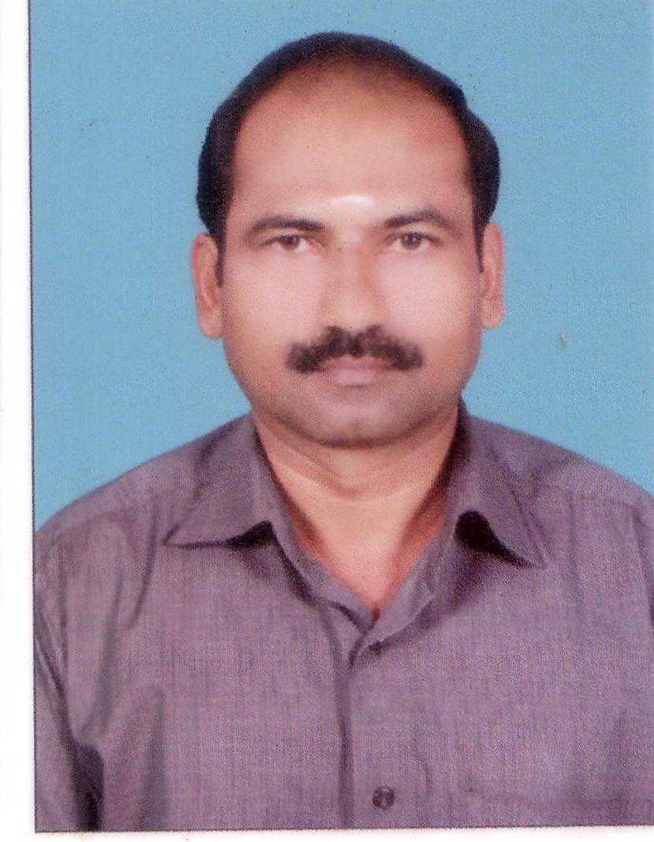
 | Mobile | 9788618630 , 9976825440
Email | 1. balakrish1972@gmail.com  2. manimegalai1977@gmail.com
Areas of Interest/  Specialization | Image Processing, Networking, Software Development
Subjects Taught | UG: PG:  1. Computer Networks 1. Digital Image Processing  2. Python Programming 2. Network Security & Cryptography  3. Visual Basic 3. Advanced Networking  4. Computer Graphics 4. Advanced Java Programming  5. Data Structures 5. Python Programming  6. System Software & O.S 6. .NET Programming  7. Digital Computer Fundamentals 7. Multimedia & Its Applications  8. Computer System Architecture 8. Distributed Computing  9. RDBMS 9. Visual Programming  10. Micro Processor & ALP 10. PHP Programming  11. Computer Fundamental & C 11. Open Source Tools  12. Java Programming  13. C++ Programming  14. Linux & Shell Programming.
Date of Joining in our Institution | 19-06-1997
Experience (in Years) | Industry |  | 1 Year
 | Teaching |  | 27 Years
 | Research |  | 19 Years
 | Total |  | 28 Years
Research Publications in Journals | 33
Papers Published in Conference Proceedings | 10

Research Projects  Major/ Minor | Completed |  | ----------
 | Undergoing |  | --------
Research Guidance | Awarded |  | Undergoing
 | - 55 |  | 1
Conferences | Attended | Presented |  |  | Organized
National | 20 | 7 |  |  | 5
International | 3 | - |  |  | 2
Workshops | Attended |  |  | Organized
 | 6 |  |  | 5
FDP | Attended |  |  | Organized
 | 6 |  |  | 2
Seminar / Webinar | Attended |  |  | Organized
 | 25 |  |  | 12
Membership | 2
Acted as Resource Person | 2
Awards | ---
Online Courses | Completed |  |  | Enrolled
 | --- |  |  | 1
Extension Activities (NSS/YRC) / Club In charge | Acted as Member in Ragging Curb ,Library Advisory, Research & Sports  Committee
Administrative Assignments Handled | Coordinator, Internal Quality Assurance Cell since 2011  Member, Disciplinary Committee since 2000
Association with Professional Bodies | Academic Council, Senate Member, University/Autonomous College Examination - Practical/ Theory Examiner, Q.P Setter  And University Representative for Bharathiar University Examination
Any other Achievements | Acted as Member for Sanctioning New Courses, Under  Bharathiar University, Coimbatore
Orchid / Google Scholar/  Research ID | https://scholar.google.com/citations?hl=en&user=0x4sy6cAAAAJ

