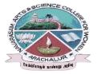
NAVARASAM ARTS AND SCIENCE COLLEGE FOR WOMEN
ARACHALUR, ERODE-638101
STAFF PROFILE
Name | MRS.K.RAMYA
Designation | 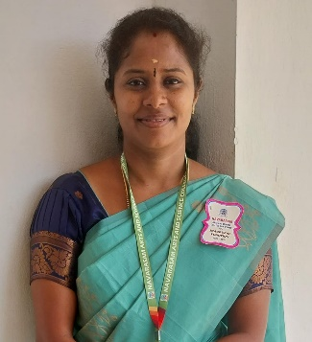  ASSISTANT PROFESSOR
Qualification | M.Sc., M.Phil.,
Department | COMPUTER SCIENCE
Phone No. | Office |  | 0424-2357209
 | Mobile |  | 9788158105
Email | 1.ramyarasu12@gmail.com
Areas of Interest/  Specialization | Data Mining
Subjects Taught | UG: PG:  1. C 1. DATA MINING & WAREHOUSING  2. C++ 2. ADVANCED SOFTWARE ENGINEERING  3. JAVA 3. MULTIMEDIA  4. MOBILE COMPUTING, 4. SOFTWARE PROJECT MANAGEMENT  5. INTERNET OF THINGS  6. LINUX,  7. ANIMATION TECHNIQUES  8. SOFTARE TESTING  9.DATA STRUCTURES  10. SESPM
Date of Joining in our Institution | 13.04.2022
Experience (in Years) | Industry |  |  | -
 | Teaching |  |  | 2.7 YEARS
 | Research |  |  | -
 | Total |  |  | 2.7 YEARS
Research Publications in Journals | 01
Papers Published in Conference Proceedings | 01
Books / Chapters  Published | -
Patent Published | -
Research Projects  Major/ Minor |  | Completed |  |  |  | -
 |  | Undergoing |  |  |  | -
Research Guidance |  | Awarded |  |  |  | Undergoing
 |  | - |  |  |  | -
Conferences |  | Attended |  |  | Presented |  |  | Organized
National |  | - |  |  | - |  |  | -
International |  | - |  |  | - |  |  | 1
Workshops |  | Attended |  |  |  |  | Organized
 |  | 4 |  |  |  |  | -
FDP |  | Attended |  |  |  |  | Organized
 |  | 6 |  |  |  |  | -
Seminar / Webinar |  | Attended |  |  |  |  | Organized
 |  | 4 |  |  |  |  | -
Membership |  | -
Acted as Resource Person |  | -
Awards |  | UNIVERSITY 6TH RANK HOLDER IN MSC(CS)
Online Courses |  | Completed |  |  |  |  | Enrolled
 |  | - |  |  |  |  | -
Extension Activities (NSS/YRC) / Club In charge |  | FOCAL POINT INCHARGE, IT-WING INCHARGE
Administrative Assignments Handled |  | PROJECT GUIDE, MENTOR, NAAN MUDHALVAN CO-ORDINATOR.
Association with Professional Bodies |  | -
Any other Achievements |  | -
Orchid / Google Scholar/  Research ID |  | -

