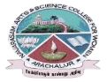
NAVARASAM ARTS AND SCIENCE COLLEGE FOR WOMEN
ARACHALUR, ERODE-638101
STAFF PROFILE
Name | Mrs. S.GOMATHI
Designation | 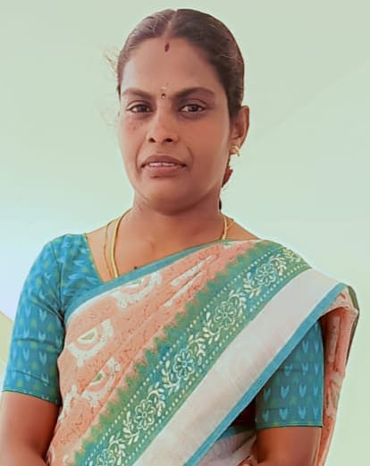  ASSISTANT PROFESSOR
Qualification | MCA., M.Phil., B.Ed,
Department | COMPUTER SCIENCE
Phone No. | Office |  | 0424-2357209
 | Mobile |  | 9688226913
Email | 1.k.g.sanjana2014@gmail.com  2.
Areas of Interest/  Specialization | Networking
Subjects Taught | UG: PG:  1. C 1. CLOUD COMPUTING  2. C++ 2. MOBILE COMPUTING  3. JAVA 3. PHP PROGRAMMING  4. VISUAL BASIC, 4. SOFT COMPUTING  5. GRAPHICS AND MULTIMEDIA, 5. ADVANCED OPERATING SYSTEM  6. SSOS,  7. WEB DESIGNING  8. RDBMS & ORACLE
Date of Joining in our Institution | 20.07.2022
Experience (in Years) | Industry |  |  | -
 | Teaching |  |  | 2. 4 YEARS
 | Research |  |  | -
 | Total |  |  | 2. 4 YEARS
Research Publications in Journals | -
Papers Published in Conference Proceedings | -
Books / Chapters  Published | -
Patent Published | -
Research Projects  Major/ Minor |  | Completed |  |  |  | -
 |  | Undergoing |  |  |  | -
Research Guidance |  | Awarded |  |  |  | Undergoing
 |  | - |  |  |  | -
Conferences |  | Attended |  |  | Presented |  |  | Organized
National |  | - |  |  | - |  |  | -
International |  | 1 |  |  | - |  |  | -
Workshops |  | Attended |  |  |  |  | Organized
 |  | 1 |  |  |  |  | -
FDP |  | Attended |  |  |  |  | Organized
 |  | 6 |  |  |  |  | 1
Seminar / Webinar |  | Attended |  |  |  |  | Organized
 |  | 2 |  |  |  |  | -
Membership |  | -
Acted as Resource Person |  | -
Awards |  | -
Online Courses |  | Completed |  |  |  |  | Enrolled
 |  | - |  |  |  |  | -
Extension Activities (NSS/YRC) / Club In charge |  | COMPUTER LEARNES CLUB
Administrative Assignments Handled |  | PROJECT GUIDE, MENTOR – MENTEE INCHARGE, SWAYAM INCHARGE.
Association with Professional Bodies |  | -
Any other Achievements |  | -
Orchid / Google Scholar/  Research ID |  | -

