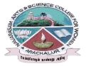
NAVARASAM ARTS AND SCIENCE COLLEGE FOR WOMEN
ARACHALUR, ERODE-638101
STAFF PROFILE
Name | MRS.S.SATHEESWARI
Designation | 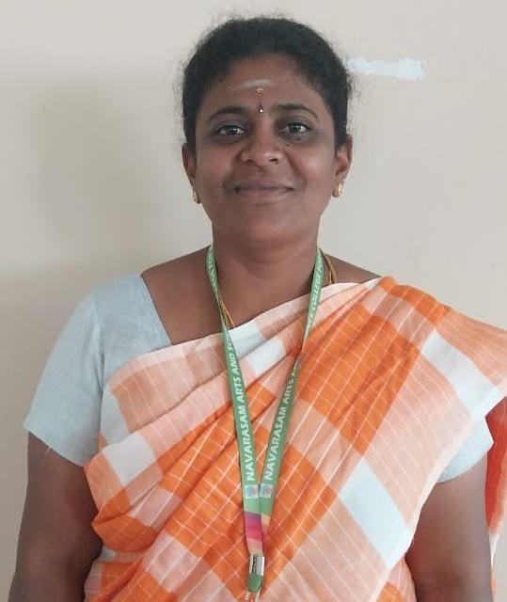  ASSISTANT PROFESSOR
Qualification | M.Sc., B.Ed.,
Department | COMPUTER SCIENCE
Phone No. | Office |  | 0424-2357209
 | Mobile |  | 9976964999
Email | 1.sakthivikashni@gmail.com
Areas of Interest/  Specialization | NETWORKING
Subjects Taught | UG:  1.C  2.C++  3.DIGITAL FUNDAMENTALS AND COMPUTER  ARCHITECTURE  4.DATA STRUCTURES  5.NET PROGRAMMING  6.SOFTWARE TESTING  7.GRAPHICS &MULTIMEDIA  8.INTERNET OF THINGS  PG:  1.ARTIFICIAL INTELLIGENCE & MACHINE LEARNING  2.ANALYSIS AND DESIGN OF ALGORITHMS  3.CLOUD COMPUTING  4.SOFT COMPUTING
Date of Joining in our Institution | 07.06.2023
Experience (in Years) | Industry |  |  | -
 | Teaching |  |  | 1.5 YEARS
 | Research |  |  | -
 | Total |  |  | 1.5 YEARS
Research Publications in Journals | -
Papers Published in Conference Proceedings | -
Books / Chapters  Published | -
Patent Published | -
Research Projects  Major/ Minor |  | Completed |  |  |  | -
 |  | Undergoing |  |  |  | -
Research Guidance |  | Awarded |  |  |  | Undergoing
 |  | - |  |  |  | -
Conferences |  | Attended |  |  | Presented |  |  | Organized
National |  | - |  |  | - |  |  | -
International |  | - |  |  | - |  |  | -
Workshops |  | Attended |  |  |  |  | Organized
 |  | - |  |  |  |  | -
FDP |  | Attended |  |  |  |  | Organized
 |  | 7 |  |  |  |  | -
Seminar / Webinar |  | Attended |  |  |  |  | Organized
 |  | - |  |  |  |  | -
Membership |  | -
Acted as Resource Person |  | -
Awards |  | -
Online Courses |  | Completed |  |  |  |  | Enrolled
 |  | - |  |  |  |  | -
Extension Activities (NSS/YRC) / Club In charge |  | -
Administrative Assignments Handled |  | SKILL DEVELOPMENT CO-ORDINATOR, NAAN MUDHALVAN IN CHARGE, CERTIFICATE COURSE IN CHARGE.
Association with Professional Bodies |  | -
Anyother Achievements |  | -
Orchid / Google Scholar/  Research ID |  | -

