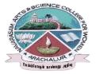
NAVARASAM ARTS AND SCIENCE COLLEGE FOR WOMEN
ARACHALUR, ERODE-638101
STAFF PROFILE
Name | MRS. V. MYTHILY
Designation | 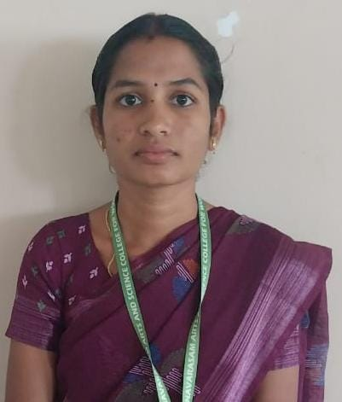  ASSISTANT PROFESSOR
Qualification | M.Sc., M.Phil.,
Department | COMPUTER SCIENCE
Phone No. | Office |  | 0424-2357209
 | Mobile |  | 9514549377
Email | 1. mythilyraja1994@gmail.com
Areas of Interest/  Specialization | DATA MINING
Subjects Taught | UG:  1.DIGITAL FUNDAMENTALS AND COMPUTER  ARCHITECTURE  2. RDBMS & ORACLE  3. NETWORK SECURITY AND CRYPTOGRAPHY  4. C++  PG:  1.ADVANCED OPERATING SYSTEM  2. ADVANCED JAVA PROGRAMMING  3.CLOUD COMPUTING  4. DATA MINING & WAREHOUSING
Date of Joining in our Institution | 01.08.2023
Experience (in Years) | Industry |  |  | -
 | Teaching |  |  | 1.5 YEARS
 | Research |  |  | -
 | Total |  |  | 1.5 YEARS
Research Publications in Journals | -
Papers Published in Conference Proceedings | -
Books / Chapters  Published | -
Patent Published | -
Research Projects  Major/ Minor |  | Completed |  |  |  | -
 |  | Undergoing |  |  |  | -
Research Guidance |  | Awarded |  |  |  | Undergoing
 |  | - |  |  |  | -
Conferences |  | Attended |  |  | Presented |  |  | Organized
National |  | - |  |  | - |  |  | -
International |  | - |  |  | - |  |  | -
Workshops |  | Attended |  |  |  |  | Organized
 |  | - |  |  |  |  | -
FDP |  | Attended |  |  |  |  | Organized
 |  | 4 |  |  |  |  | -
Seminar / Webinar |  | Attended |  |  |  |  | Organized
 |  | - |  |  |  |  | -
Membership |  | -
Acted as Resource Person |  | -
Awards |  | -
Online Courses |  | Completed |  |  |  |  | Enrolled
 |  | - |  |  |  |  | -
Extension Activities (NSS/YRC) / Club In charge |  | -
Administrative Assignments Handled |  | CERTIFICATE COURSE IN CHARGE
Association with Professional Bodies |  | -
Anyother Achievements |  | -
Orchid / Google Scholar/  Research ID |  | -

