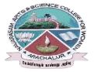
NAVARASAM ARTS AND SCIENCE COLLEGE FOR WOMEN
ARACHALUR, ERODE-638101
STAFF PROFILE
Name | K.Sumithra.  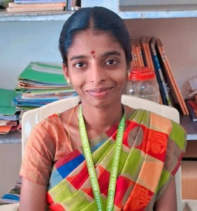
Designation | Assistant Professor
Qualification | MA
Department | Tamil
Phone No. | Office
 | Mobile | 9976765443
Email | 1.sumivijay5899@gmail.com  2.
Areas of Interest/  Specialization | Ilakkiyam  Ilakanam
Subjects Taught | UG: PG:  Tharkalailakiyayam. Sangailakiyam.  Nanool. Tholkapiyam
Date of Joining in our Institution | 21.08.2023
Experience (in Years) | Industry |  | Nil
 | Teaching |  | Nil
 | Research |  | Nil
 | Total |  | Nil
Research Publications in Journals | Nil
Papers Published in Conference Proceedings | Nil
Books / Chapters  Published | Nil
Patent Published | Nil

Research Projects  Major/ Minor | Completed |  | Nil
 | Undergoing |  | Nil
Research Guidance | Awarded |  | Undergoing
 | Nil |  | Nil
Conferences | Attended | Presented |  |  | Organized
National | Nil | Nil |  |  | Nil
International
Workshops | Attended |  |  | Organized
 | Nil |  |  | Nil
FDP | Attended |  |  | Organized
 | 2 |  |  | Nil
Seminar / Webinar | Attended |  |  | Organized
 | Nil |  |  | Nil
Membership | Nil
Acted as Resource Person | Nil
Awards | Nil
Online Courses | Completed |  |  | Enrolled
 | Nil |  |  | Nil
Extension Activities (NSS/YRC) / Club In charge | Nil
Administrative Assignments Handled | Nil
Association with Professional Bodies | Nil
Anyother Achievements | Nil
Orchid / Google Scholar/  Research ID | Nil

