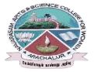
NAVARASAM ARTS AND SCIENCE COLLEGE FOR WOMEN
ARACHALUR, ERODE-638101
STAFF PROFILE
Name | S.LAKSHMI  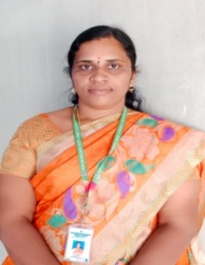
Designation | ASSISTANT PROFEESOR
Qualification | M.A,M.PHIL,(Ph.D)
Department | TAMIL
Phone No. | Office
 | Mobile |  | 9597464889
Email | 1.abhinavsibi@gmail.com  2.
Areas of Interest/  Specialization | IKAALA ILAKKIYAM  FOLKLORE
Subjects Taught | UG: URAINADAI ILAKKIYAM  ITHAZHIYAL  YAAPPU THANDI ILAKKANAM  POTHUMOLIYIYAL  PG: SITRILAKKIYAM  BAKTHI ILAKKIYAM
Date of Joining in our Institution | 07.06.2023
Experience (in Years) | Industry
 | Teaching |  |  | 1.5
 | Research
 | Total
Research Publications in Journals | 2
Papers Published in Conference Proceedings | -
Books / Chapters  Published | -
- Patent Published | -
Research Projects  Major/ Minor |  | Completed |  |  |  | -
 |  | Undergoing |  |  |  | -
Research Guidance |  | Awarded |  |  |  | Undergoing
 |  | - |  |  |  | -
Conferences |  | Attended |  |  | Presented |  |  | Organized
National |  | - |  |  | - |  |  | -
International |  | - |  |  | - |  |  | -
Workshops |  | Attended |  |  |  |  | Organized
 |  | - |  |  |  |  | -
FDP |  | Attended |  |  |  |  | Organized
 |  | 3 |  |  |  |  | -
Seminar / Webinar |  | Attended |  |  |  |  | Organized
 |  | 2 |  |  |  |  | -
Membership |  | -
Acted as Resource Person |  | -
Awards |  | -
Online Courses |  | Completed |  |  |  |  | Enrolled
 |  | - |  |  |  |  | -
Extension Activities (NSS/YRC) / Club In charge |  | VIVEGANANTHAR MANRAM
Administrative Assignments Handled |  | -
Association with Professional Bodies |  | -
Anyother Achievements |  | -
Orchid / Google Scholar/  Research ID |  | -

