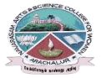
NAVARASAM ARTS AND SCIENCE COLLEGE FOR WOMEN
ARACHALUR, ERODE-638101
STAFF PROFILE
Name | T.S.Shiyamalavalli.  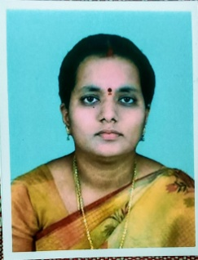
Designation | Associate professor
Qualification | M.A, M.phil, Ph.D
Department | Tamil
Phone No. | Office | NIL
 | Mobile | 9965712387
Email | 1. shiyamyaazhini@gmail.com
Areas of Interest/  Specialization | Illakanam
Subjects Taught | UG: sangailakiyam PG: ilakanam
Date of Joining in our Institution | 16.12.20111
Experience (in Years) | Industry |  | __
 | Teaching |  | 24
 | Research |  | __
 | Total |  | 24
Research Publications in Journals | 1
Papers Published in Conference Proceedings | 12
Books / Chapters  Published | 3
Patent Published | Nil

Research Projects  Major/ Minor | Completed |  | Nil
 | Undergoing |  | Nil
Research Guidance | Awarded |  | Undergoing
 | M.phil -5 |  | Nil
Conferences | Attended | Presented |  |  | Organized
National | 8 | 8 |  |  | Nil
International | 2 | 2 |  |  | Nil
Workshops | Attended |  |  | Organized
 | Nil |  |  | Nil
FDP | Attended |  |  | Organized
 | 30 |  |  | Nil
Seminar / Webinar | Attended |  |  | Organized
 | 20 |  |  | Nil
Membership | Nil
Acted as Resource Person | Nil
Awards | Nil
Online Courses | Completed |  |  | Enrolled
 | Nil |  |  | Nil
Extension Activities (NSS/YRC) / Club In charge | Toya making  Thirukural peravai  Fine Arts
Administrative Assignments Handled | Nil
Association with Professional Bodies | Nil
Anyother Achievements | Nil
Orchid / Google Scholar/  Research ID | Nil

