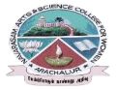
NAVARASAM ARTS AND SCIENCE COLLEGE FOR WOMEN
ARACHALUR, ERODE-638101
STAFF PROFILE
Name | T.Ilavarasi. 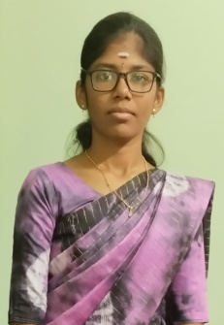
Designation | Assistant Professor
Qualification | MA.,B.ed.,Net
Department | Tamil
Phone No. | Office
 | Mobile |  | 9361743115
Email | 1.ilanthamililavarasi@gmail.com  2.
Areas of Interest/  Specialization | Ikkala ilakiyam
Subjects Taught | UG: PG:  Tamil ilakiya varalaru. Ara ilakiyam.  Tamil mozhi varalaru. Kongu nattiyal.  Mozhipeyarpiyal. Nattupuraviyal  Puruporl venbamalai
Date of Joining in our Institution | 1.10.2021
Experience (in Years) | Industry |  |  | Nil
 | Teaching |  |  | 3
 | Research |  |  | Nil
 | Total |  |  | 3
Research Publications in Journals | Nil
Papers Published in Conference Proceedings | Nil
Books / Chapters  Published | 1
Patent Published | Nil
Research Projects  Major/ Minor |  | Completed |  |  |  | Nil
 |  | Undergoing |  |  |  | Nil
Research Guidance |  | Awarded |  |  |  | Undergoing
 |  | Nil |  |  |  | Nil
Conferences |  | Attended |  |  | Presented |  |  | Organized
National |  | Nil |  |  | Nil |  |  | Nil
International |  | Nil |  |  | Nil |  |  | Nil
Workshops |  | Attended |  |  |  |  | Organized
 |  | Nil |  |  |  |  | Nil
FDP |  | Attended |  |  |  |  | Organized
 |  | 3 |  |  |  |  | Nil
Seminar / Webinar |  | Attended |  |  |  |  | Organized
 |  | Nil |  |  |  |  | Nil
Membership |  | Nil
Acted as Resource Person |  | Nil
Awards |  | Nil
Online Courses |  | Completed |  |  |  |  | Enrolled
 |  | 3 |  |  |  |  | Nil
Extension Activities (NSS/YRC) / Club In charge |  | Nil
Administrative Assignments Handled |  | Nil
Association with Professional Bodies |  | Nil
Anyother Achievements |  | Nil
Orchid / Google Scholar/  Research ID |  | Nil

